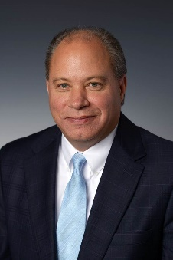
DISTRICT #1 VICE PRESIDENT APPLICATION
Candidate Name: John Royer

Local Board/Association Columbus REALTORS

Company Kohr Royer Griffith, Inc.

1. Has the candidate served as an Officer,
Trustee/Director of his/her Local Board?
Yes

Year(s) President-2016, President Elect-2015, Treasurer, 2014, Secretary 2013,
Director 2005, 2017

Name of Local Board Columbus REALTORS

2. Has the candidate served as an Ohio
Yes

REALTORS Director for at least two years (not
necessarily in succession) or one year as a
Director and one year as an Alternate Director?

Year(s) Director 2002, 2005-2007, 2012-2018

3. Has the candidate served as an active
Yes

committee member of at least one Ohio
REALTORS committee during the last three years?

Committee(s) RPAC Trustees 2017-2019, Ohio My REALTOR Party 2018, Res. Property
Management & Investment Forum 2016

Year(s) See above

4. Has the candidate been licensed by the state
and a member of the Ohio REALTORS for a minimum of five years?
Yes

Year Licensed: 1987

5. Has the candidate attended at least two Ohio REALTORS Conventions within the last three years? (Indicate the years attended)
Yes

Years attended: 2017, 2016, 2015

JOHN W. ROYER

President
Commercial Real Estate Services

Experience / Professional History
John W. Royer, over the last twenty eight years, has been involved in all
aspects of real estate including; brokerage, development and counseling of numerous projects.
He has acquired, disposed and/or leased over $400 million dollars in real property. John has acted as a development consultant and developer for various clients in sale/lease back transactions. He has been involved in the renovation, development, and investment in over $150 million dollars of real property. Additionally, he has worked with clients; on-site acquisitions, disposals, tenant representation, bank owned real estate and receiver work. John lives in Upper Arlington with his wife Stacey. They have 3 daughters Hannah, Libby and Sari.

Licensed
Real Estate Broker State of Ohio
Real Estate Broker State of Kentucky
Franklin County Probate Court Real Estate Appraiser

Professional Affiliations
Counselors of Real Estate (CRE)
Society of Industrial and Office Realtors (SIOR)
International Council of Shopping Center (ICSC)
2016 President for Columbus Realtors (CR)
Ohio Association of Realtors (OAR)
National Association of Realtors (NAR)

Board Positions
First Merchants Local Central Ohio Board
Chair—Community Housing Network, Inc.
Salvation Army Adult Rehabilitation Center (ARC)
OSU Center for Real Estate Advisory Board (2017)
State of Ohio Housing Trust Fund Advisory Committee (2017-2021)

