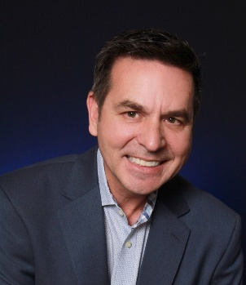

TREASURER CANDIDATE APPLICATION

Candidate's Name: John Mangas

Local Board/Association Toledo Regional Association of Realtors

Company RE/MAX Preferred Associates

1. Has the candidate served as President of his/her Local Board of REALTORS or as an officer of the National Association of REALTORS or any of its Institutes?
Yes

Year 2014

Name of Local Board Toledo Regional Association of Realtors

2. Has the candidate served as a Director or
Alternate Director to the Ohio REALTORS for at least two years (not necessarily in succession)? (indicate the years)
Yes

Year(s) Director 2006-present
Year(s) Alternate n/a

3. Has the candidate served as an active
Yes

committee member of at least one Ohio
REALTORS committee during the last three years?
(indicate the years)

Committee(s) Enlarged Legislative, Legislative Steering, Finance, Issues Mobilization,
Strategic Planning, Professional Development, Convention Committee, Executive Committee, Business Technologies,

Year(s) see attached

4. Has the candidate been licensed by the state
and a member of the Ohio REALTORS for a minimum of eight years? (indicate year licensed)
Yes

Year Licensed: 1981

5. Has the candidate attended at least two Ohio REALTORS Conventions within the last
three years? (Indicate the years attended)

Years attended:
Yes

Thinking I haven’t missed an OR convention in 20+ years

Toledo Regional Association of REALTORS®
Pre sident-2014
Citizen of the Year-2016
RPAC Chair-2016
Legislative & Government Affairs
Committee Chair-2013 & 2016

Northwest Ohio Real Estate Information Service
(NORIS MLS)
President-2006-2009 & 2016-2017
Director-2003-Present

Ohio REALTORS® Leadership
Enlarged Legislative Committee Chair-2018
Legislative Steering Committee Chair-2018
Finance C omm tee-2018
New Ohio REALTORS® Executive Office Task Force-2018
Issues Mobilization Subocomm tee-2016-2018
Pre-License Background Check Task Force-2017
Structure & Governance Review Task Force Member-20 17
Local Gov ernment Forum Chair-2017
ProfessionalDevelopment Committee Chair-2017
Strategic Planning Committee-2015-2017
Convention Committee Chair-2016
Executive Committee-2015 & 2016
Business Technology Forum Chair-2014
Earnest Money Task Force
Ohio REALTORS® Director-2006-Present

National Association of REALTORS®
Sterling R lnv estor-2014-2018
Single Family Investment Management Council-2018
Broker Advisory Council
Attended Midyear Meetings 2013-2018
Attended NAR Conventions 2013-2018
